2. Create a "Dynamic Web Project"

Create a dynamic web project by using the default setting.

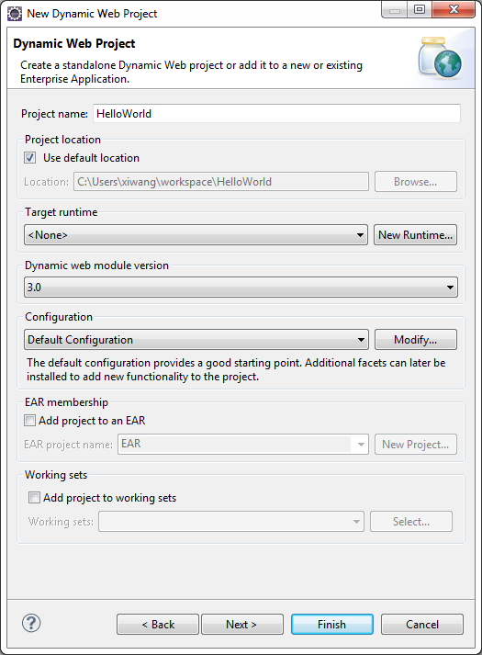

After creation, the project explorer view should show:

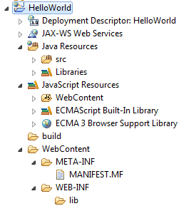

3. Create a index.jsp file

Create an .jsp file named with "index.jsp" under "WebContent" directory. Right click "webContent" --> New --> JSP File. Change the code generated to be the following:

|  |
| --- |
| <%@ page language="java" contentType="text/html; charset=ISO-8859-1"  pageEncoding="ISO-8859-1"%>  <!DOCTYPE html PUBLIC "-//W3C//DTD HTML 4.01 Transitional//EN" "http://www.w3.org/TR/html4/loose.dtd">  <html>  <head>  <meta http-equiv="Content-Type" content="text/html; charset=ISO-8859-1">  <title>Hello World </title>  </head>  <body>    <h1>  Hello World  </h1>  </body>  </html> |

4. Create a new server

As a web project runs on an HTTP server, a new server should be setup to hold the web project.

Download Tomcat 7.0 [here](http://tomcat.apache.org/download-70.cgi). Download the core Zip version, and unzip it to a directory (remember this directory). In your eclipse, create a new Server.

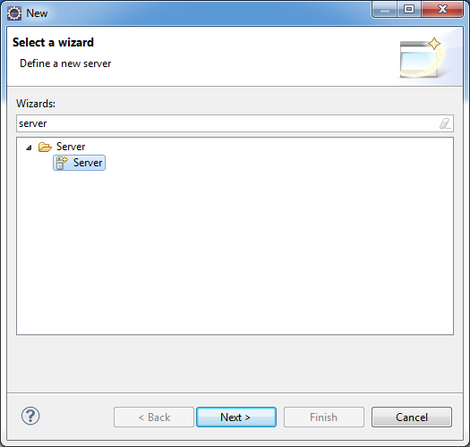

Select the directory where you unzipped the tomcat.

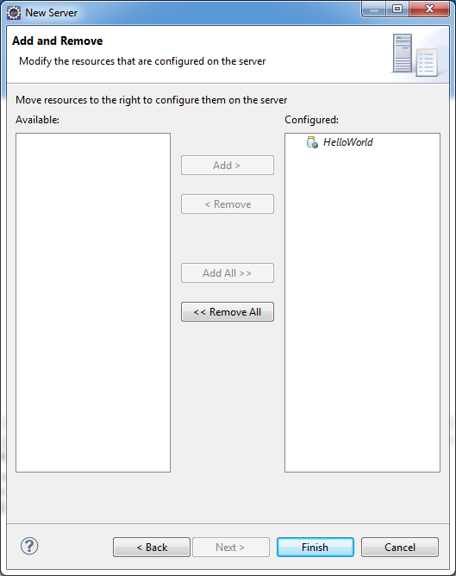

Run the project on server, and you should have a welcome page as follows:

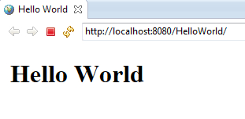

5. Add Spring Framework support

Download: Spring Framework 3.1.0.RELEASE is the current production release (requires Java 1.5+)  
From: http://www.springsource.org/download  
Add the following jar files to "WebContent/WEB-INF/lib" directory.

commons-logging-1.1.1.jar

commons-logging-api-1.1.1.jar

spring-asm-3.2.0.M1.jar

spring-beans-x.jar

spring-content-x.jar

spring-core-x.jar

spring-expression-x.jar

spring-instrument-x.jar

spring-web-x.jar

spring-webmvc-x.jar

6. Create Spring MVC

Change web.xml file to be the following:

|  |
| --- |
| **<?xml** version="1.0" encoding="UTF-8"**?>**  **<web-app** xmlns:xsi="http://www.w3.org/2001/XMLSchema-instance" xmlns="http://java.sun.com/xml/ns/javaee" xmlns:web="http://java.sun.com/xml/ns/javaee/web-app_2_5.xsd" xsi:schemaLocation="http://java.sun.com/xml/ns/javaee http://java.sun.com/xml/ns/javaee/web-app_2_5.xsd" id="WebApp_ID" version="2.5"**>**  **<display-name>**HelloSpring**</display-name>**    **<servlet>**  **<servlet-name>**springapp**</servlet-name>**  **<servlet-class>**org.springframework.web.servlet.DispatcherServlet**</servlet-class>**  **<load-on-startup>**1**</load-on-startup>**  **</servlet>**    **<servlet-mapping>**  **<servlet-name>**springapp**</servlet-name>**  **<url-pattern>**\*.htm**</url-pattern>**  **</servlet-mapping>**    **<welcome-file-list>**  **<welcome-file>**index.html**</welcome-file>**  **<welcome-file>**index.htm**</welcome-file>**  **<welcome-file>**index.jsp**</welcome-file>**  **<welcome-file>**default.html**</welcome-file>**  **<welcome-file>**default.htm**</welcome-file>**  **<welcome-file>**default.jsp**</welcome-file>**  **</welcome-file-list>**  **</web-app>** |

Create springapp-servlet.xml file under WEB-INF direction and copy the following to it:

|  |
| --- |
| **<?xml** version="1.0" encoding="UTF-8"**?>**    **<beans** xmlns="http://www.springframework.org/schema/beans"  xmlns:xsi="http://www.w3.org/2001/XMLSchema-instance"  xsi:schemaLocation="http://www.springframework.org/schema/beans  http://www.springframework.org/schema/beans/spring-beans-2.5.xsd"**>**    *<!-- the application context definition for the springapp DispatcherServlet -->*    **<bean** name="/hello.htm" class="springapp.web.HelloController"**/>**    **</beans>** |

Create a class inside "Java Resources" as follows:

|  |
| --- |
| **package** springapp.web;    **import** javax.servlet.http.HttpServletRequest;  **import** javax.servlet.http.HttpServletResponse;    **import** org.springframework.web.servlet.ModelAndView;  **import** org.springframework.web.servlet.mvc.Controller;    **public** **class** HelloController **implements** Controller {    @Override  **public** ModelAndView handleRequest(HttpServletRequest arg0, HttpServletResponse arg1) **throws** Exception {  *// TODO Auto-generated method stub*  **return** **new** ModelAndView("hello.jsp");  }    } |

